3. Duplicate Record Removal

Aim
To identify and remove duplicate records from a customer dataset using Pandas.

Explanation
Duplicate records occur when the same row appears multiple times in a dataset. These duplicates can affect data analysis and lead to inaccurate results. Pandas provides the duplicated() function to identify duplicate rows and the drop_duplicates() function to remove them, ensuring that the dataset contains only unique records.

Python Code
import pandas as pd

# Create a sample customer dataset
data = {
"Customer_ID": [101, 102, 103, 101, 104, 105, 102],
"Name": ["John", "Alice", "Bob", "John", "David", "Eva", "Alice"],
"City": ["Chennai", "Delhi", "Mumbai", "Chennai", "Pune", "Hyderabad", "Delhi"]
}

df = pd.DataFrame(data)

print("Original Dataset")
print(df)

# Find duplicate records
duplicates = df[df.duplicated()]

print("\nDuplicate Records")
print(duplicates)

# Remove duplicate records
df = df.drop_duplicates()

print("\nDataset After Removing Duplicates")
print(df)

Output

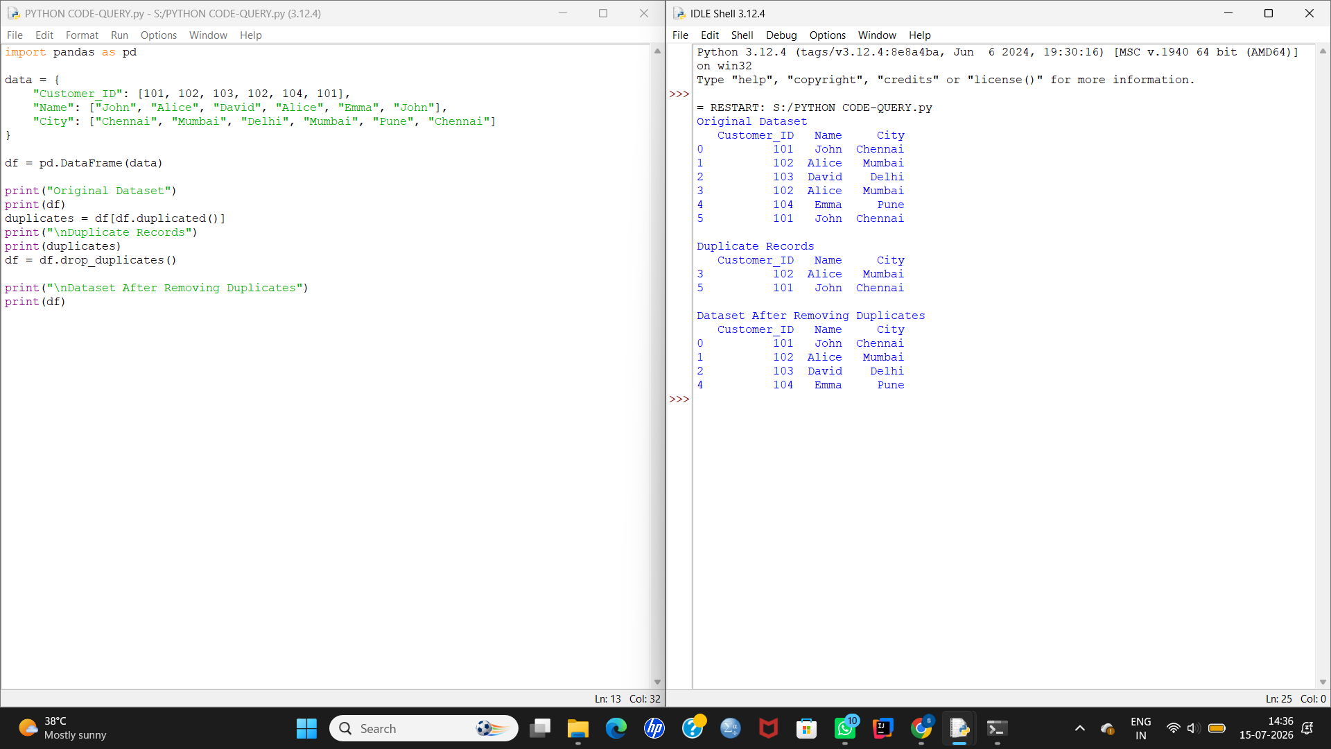

Conclusion
The duplicate records were successfully identified and removed using the duplicated() and drop_duplicates() functions, resulting in a clean dataset without repeated entries.

4. Sorting Dataset

Aim
To sort a sales dataset based on sales amount and display the top 10 highest-selling products.

Explanation
Sorting arranges the dataset in ascending or descending order based on a specific column. The sort_values() function is used to sort the data, and the head() function displays the first 10 records after sorting.

Python Code
import pandas as pd

# Create a sample sales dataset
data = {
"Product": ["Laptop", "Mouse", "Keyboard", "Monitor", "Printer",
"Tablet", "Speaker", "Camera", "Phone", "TV",
"Watch", "Headset"],
"Sales": [95000, 12000, 18000, 45000, 30000,
60000, 25000, 80000, 90000, 70000,
22000, 17000]
}

df = pd.DataFrame(data)

print("Original Dataset")
print(df)

# Sort by Sales in descending order
sorted_df = df.sort_values(by="Sales", ascending=False)

print("\nTop 10 Highest-Selling Products")
print(sorted_df.head(10))

Output

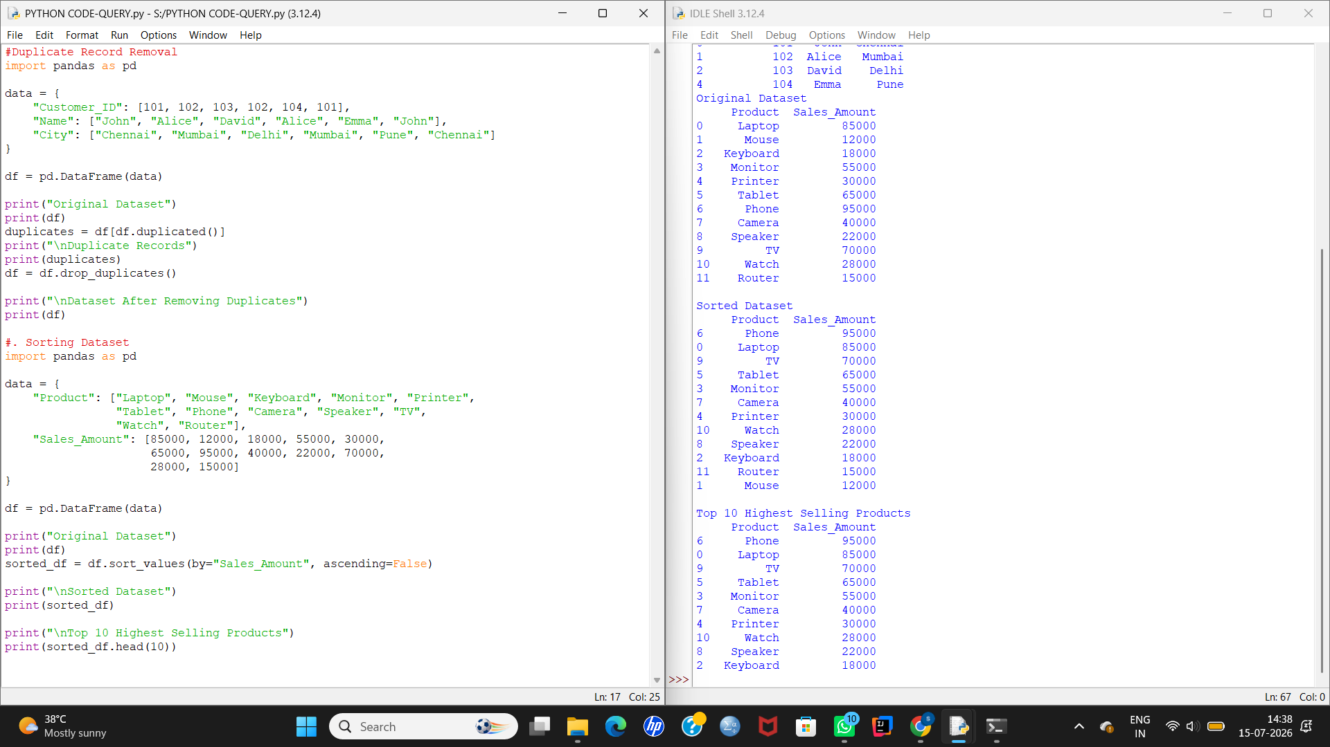

Conclusion
The dataset was successfully sorted in descending order based on sales, and the top 10 highest-selling products were displayed.

5. Filtering Records

Aim
To filter patient records based on age, gender, and diabetes status using Pandas.

Explanation
Filtering is used to extract records that satisfy a particular condition. Boolean indexing in Pandas allows us to filter rows based on one or more conditions such as age, gender, or disease status.

Python Code
import pandas as pd

# Create a sample hospital dataset
data = {
"Patient_ID": [1, 2, 3, 4, 5, 6],
"Name": ["John", "Alice", "David", "Sara", "Tom", "Emma"],
"Age": [65, 45, 72, 68, 30, 80],
"Gender": ["Male", "Female", "Male", "Female", "Male", "Female"],
"Diabetic": ["Yes", "No", "Yes", "No", "Yes", "Yes"]
}

df = pd.DataFrame(data)

print("Hospital Dataset")
print(df)

# Patients above 60
print("\nPatients Above 60 Years")
print(df[df["Age"] > 60])

# Female patients
print("\nFemale Patients")
print(df[df["Gender"] == "Female"])

# Count diabetic patients
count = df[df["Diabetic"] == "Yes"].shape[0]

print("\nNumber of Diabetic Patients:", count)

Output

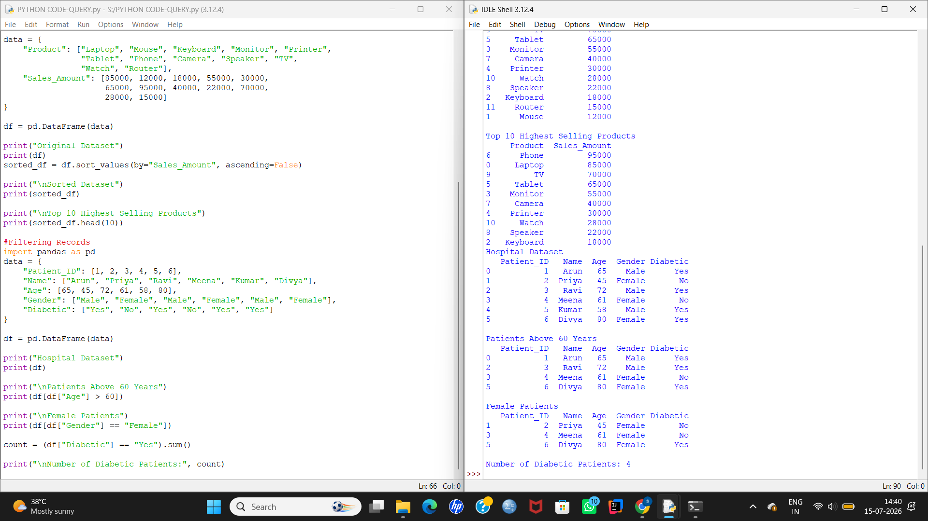

Conclusion
The dataset was successfully filtered to display patients above 60 years of age and female patients. Additionally, the total number of diabetic patients was counted using conditional filtering in Pandas. This demonstrates how filtering techniques can be used to retrieve meaningful information from large healthcare datasets.

8. Data Aggregation

Aim
To perform data aggregation on a monthly sales dataset by calculating the total, average, maximum, and minimum sales using Pandas.

Explanation
Data aggregation is the process of summarizing data using statistical functions. Pandas provides built-in methods such as sum(), mean(), max(), and min() to perform aggregation efficiently. These operations help analyze sales performance over a period of time.

Python Code
import pandas as pd

# Create a sample monthly sales dataset
data = {
"Month": ["Jan", "Feb", "Mar", "Apr", "May", "Jun"],
"Sales": [45000, 52000, 48000, 61000, 57000, 69000]
}

df = pd.DataFrame(data)

print("Monthly Sales Dataset")
print(df)

# Calculate aggregations
total_sales = df["Sales"].sum()
average_sales = df["Sales"].mean()
maximum_sales = df["Sales"].max()
minimum_sales = df["Sales"].min()

print("\nTotal Sales:", total_sales)
print("Average Sales:", average_sales)
print("Maximum Sales:", maximum_sales)
print("Minimum Sales:", minimum_sales)

Output

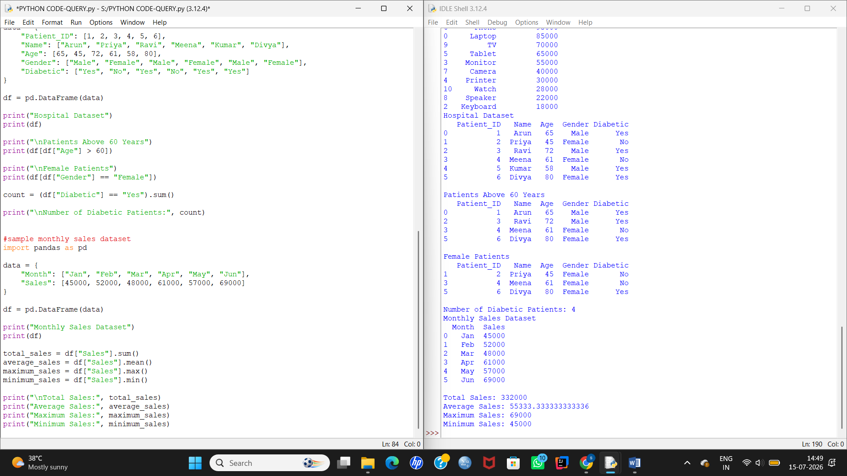

Conclusion
The monthly sales data was successfully aggregated using Pandas. The total, average, maximum, and minimum sales values were calculated, providing a quick statistical summary of the dataset.

9. Grouping Data

Aim
To group employees by department and calculate the total salary, average salary, and employee count.

Explanation
Grouping is a powerful data analysis technique used to organize records based on a common attribute. The groupby() function in Pandas groups the data by a specified column, while the agg() function performs multiple aggregation operations such as sum, mean, and count on each group.

Python Code
import pandas as pd

# Create a sample employee dataset
data = {
"Employee_ID": [101, 102, 103, 104, 105, 106],
"Employee_Name": ["John", "Alice", "Bob", "David", "Eva", "Tom"],
"Department": ["HR", "IT", "IT", "Finance", "HR", "Finance"],
"Salary": [35000, 60000, 55000, 70000, 40000, 65000]
}

df = pd.DataFrame(data)

print("Employee Dataset")
print(df)

# Group by Department
grouped = df.groupby("Department").agg(
Total_Salary=("Salary", "sum"),
Average_Salary=("Salary", "mean"),
Employee_Count=("Salary", "count")
)

print("\nDepartment-wise Summary")
print(grouped)

Output

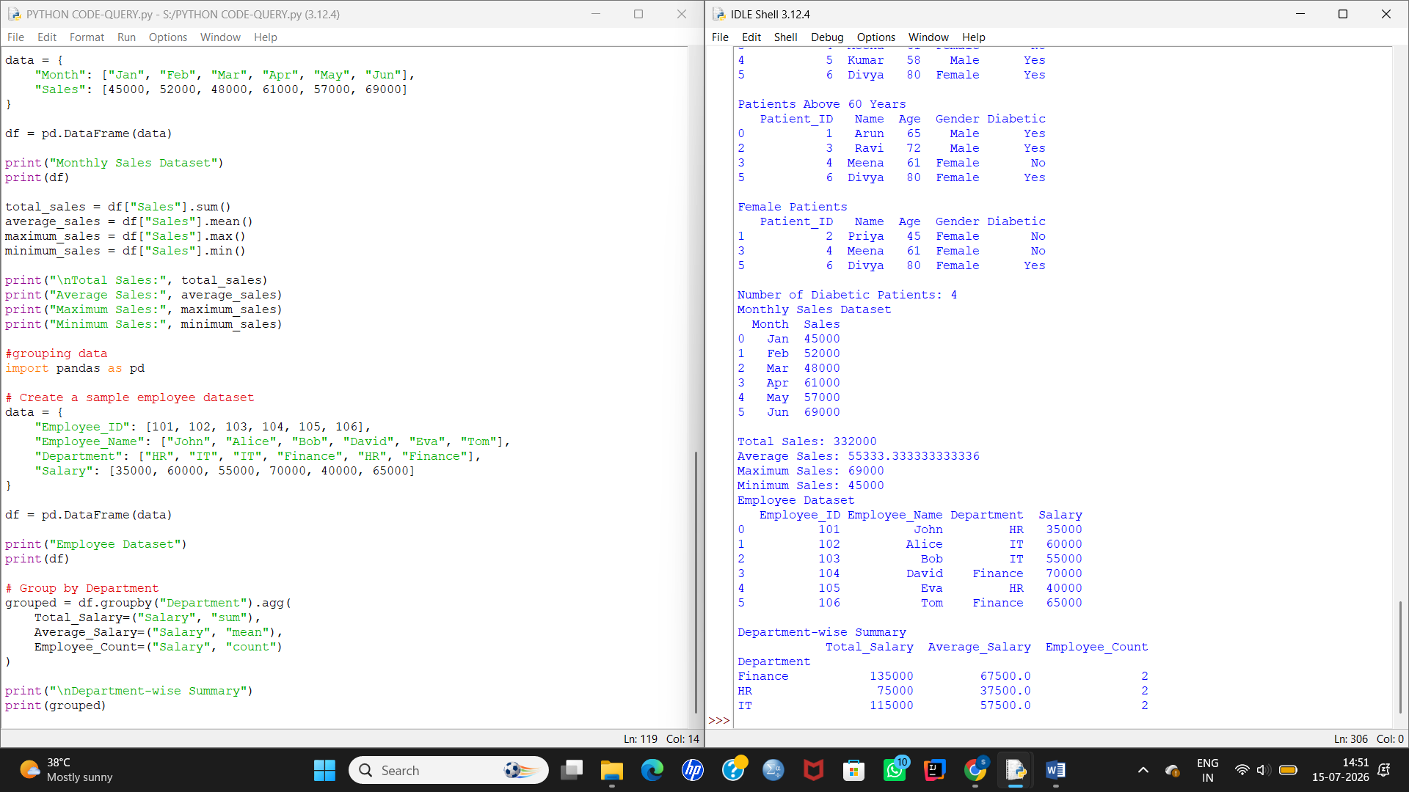

Conclusion
The employees were successfully grouped according to their departments. The total salary, average salary, and employee count for each department were calculated using the groupby() and agg() functions.

10. Merge Two CSV Files

Aim
To merge two CSV files (employees.csv and departments.csv) using the Department ID.

Explanation
Merging combines data from multiple datasets based on a common column. In Pandas, the merge() function is used to join two DataFrames. This operation is similar to SQL joins and is useful when related information is stored in different files.

Python Code
import pandas as pd

# Read the CSV files
employees = pd.read_csv("employees.csv")
departments = pd.read_csv("departments.csv")

print("Employees Dataset")
print(employees)

print("\nDepartments Dataset")
print(departments)

# Merge using Department_ID
merged_data = pd.merge(employees, departments, on="Department_ID")

print("\nMerged Dataset")
print(merged_data)

Output

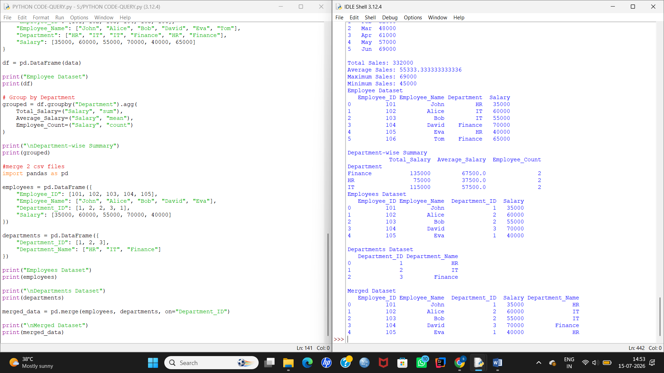

Conclusion
The two CSV files were successfully merged using the common Department_ID column. The resulting dataset contains employee details along with their corresponding department names, demonstrating how the merge() function combines related data from multiple sources.

15. XML to DataFrame

Aim
To convert XML data into a Pandas DataFrame.

Explanation
XML (eXtensible Markup Language) is a common format used for storing and exchanging structured data. Python's xml.etree.ElementTree module is used to parse XML data, and the extracted information is stored in a Pandas DataFrame for easy analysis and manipulation.

Python Code (Run Directly)
import pandas as pd
import xml.etree.ElementTree as ET

# XML data
xml_data = """
<products>
<product>
<id>101</id>
<name>Laptop</name>
<price>65000</price>
</product>
<product>
<id>102</id>
<name>Mouse</name>
<price>1200</price>
</product>
<product>
<id>103</id>
<name>Keyboard</name>
<price>2500</price>
</product>
</products>
"""

# Parse XML
root = ET.fromstring(xml_data)

# Convert XML to list
data = []

for product in root.findall("product"):
data.append({
"ID": product.find("id").text,
"Product": product.find("name").text,
"Price": int(product.find("price").text)
})

# Create DataFrame
df = pd.DataFrame(data)

print("Products DataFrame")
print(df)

Output

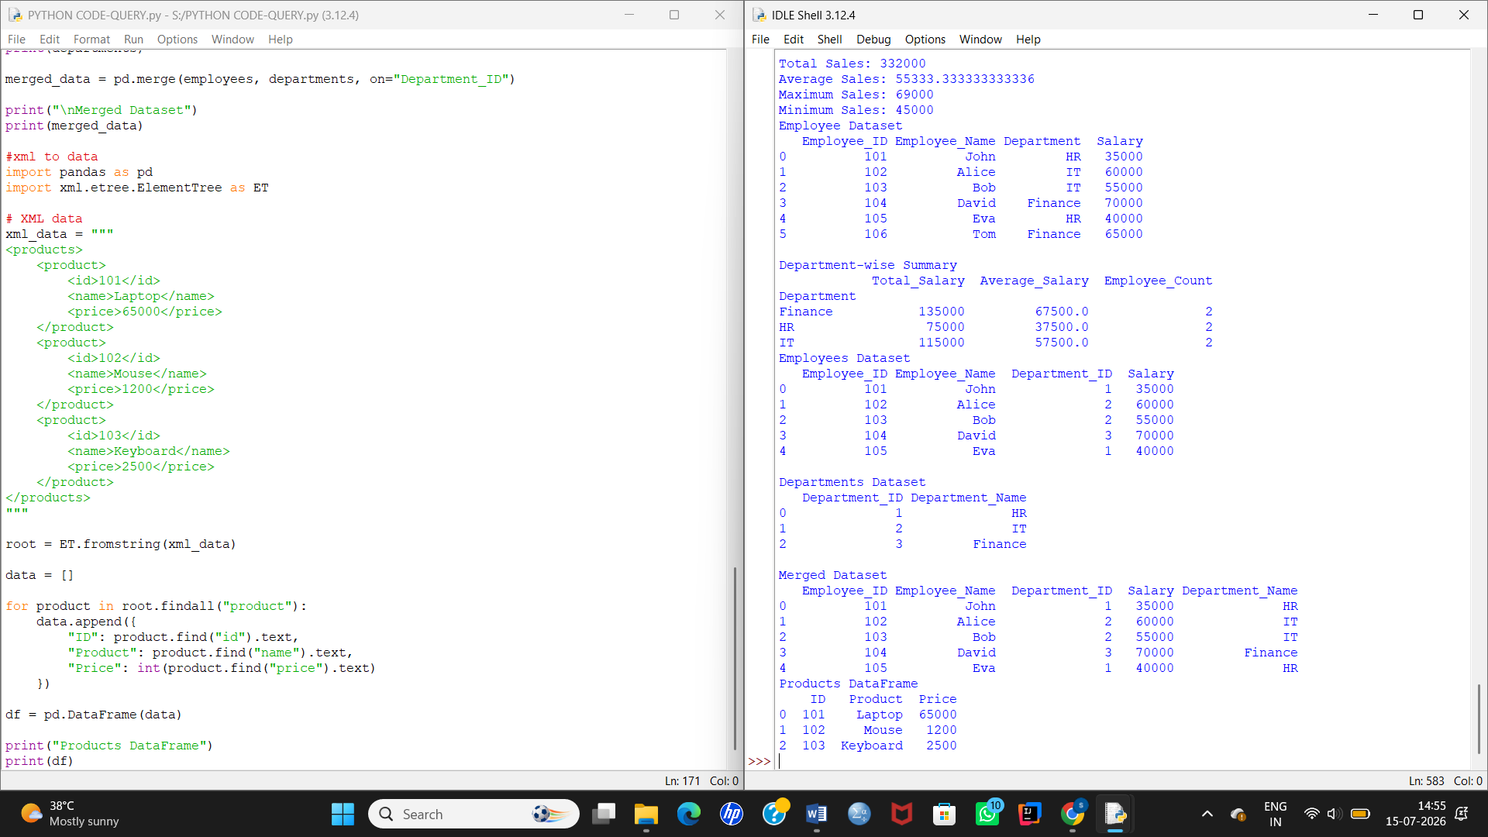Conclusion
The XML data was successfully parsed and converted into a Pandas DataFrame, making it easy to analyze and manipulate the product information.

16. XML Data Analysis

Aim
To analyze a library XML dataset by displaying the total number of books, books published after 2020, and books costing more than ₹500.

Explanation
XML data is parsed using the ElementTree module. After extracting the required fields, the data is stored in a Pandas DataFrame. The DataFrame is then analyzed using filtering and counting operations.

Python Code (Run Directly)
import pandas as pd
import xml.etree.ElementTree as ET

# XML data
xml_data = """
<library>
<book>
<title>Python Basics</title>
<author>John</author>
<year>2019</year>
<price>450</price>
</book>
<book>
<title>Data Science</title>
<author>Alice</author>
<year>2022</year>
<price>650</price>
</book>
<book>
<title>Machine Learning</title>
<author>David</author>
<year>2023</year>
<price>800</price>
</book>
<book>
<title>AI Fundamentals</title>
<author>Emma</author>
<year>2021</year>
<price>550</price>
</book>
</library>
"""

# Parse XML
root = ET.fromstring(xml_data)

books = []

for book in root.findall("book"):
books.append({
"Title": book.find("title").text,
"Author": book.find("author").text,
"Year": int(book.find("year").text),
"Price": int(book.find("price").text)
})

df = pd.DataFrame(books)

print("Library Dataset")
print(df)

print("\nTotal Books:", len(df))

print("\nBooks Written After 2020")
print(df[df["Year"] > 2020])

print("\nBooks Costing More Than ₹500")
print(df[df["Price"] > 500])

Output

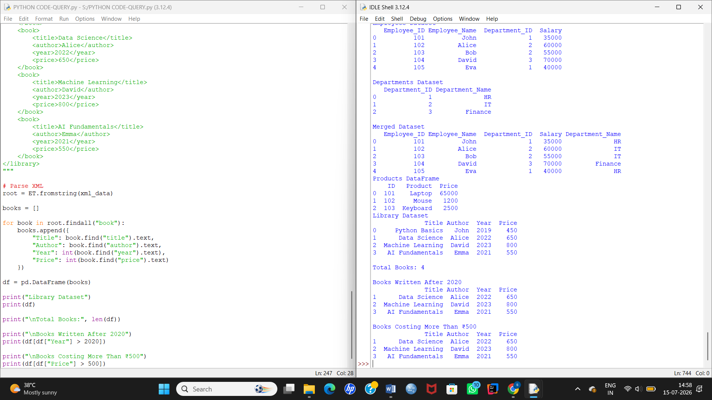

Conclusion
The XML library data was successfully converted into a DataFrame. The total number of books, books published after 2020, and books costing more than ₹500 were displayed using DataFrame filtering techniques.

17. Data Interpretation using Python

Aim
To store student marks in a list and find the highest mark, lowest mark, average mark, and the number of students who passed.

Explanation
Lists are used to store multiple student marks. Built-in Python functions such as max(), min(), and sum() help calculate the highest mark, lowest mark, and average mark. A loop is used to count the number of students who scored 35 or more, which is considered the passing mark.

Python Code
# List of student marks
marks = [78, 56, 92, 35, 48, 67, 25, 89, 41, 30]

print("Student Marks")
print(marks)

# Highest mark
highest = max(marks)

# Lowest mark
lowest = min(marks)

# Average mark
average = sum(marks) / len(marks)

# Count passed students (Pass mark = 35)
passed = 0

for mark in marks:
if mark >= 35:
passed += 1

print("\nHighest Mark:", highest)
print("Lowest Mark:", lowest)
print("Average Mark:", average)
print("Number of Students Passed:", passed)

Output

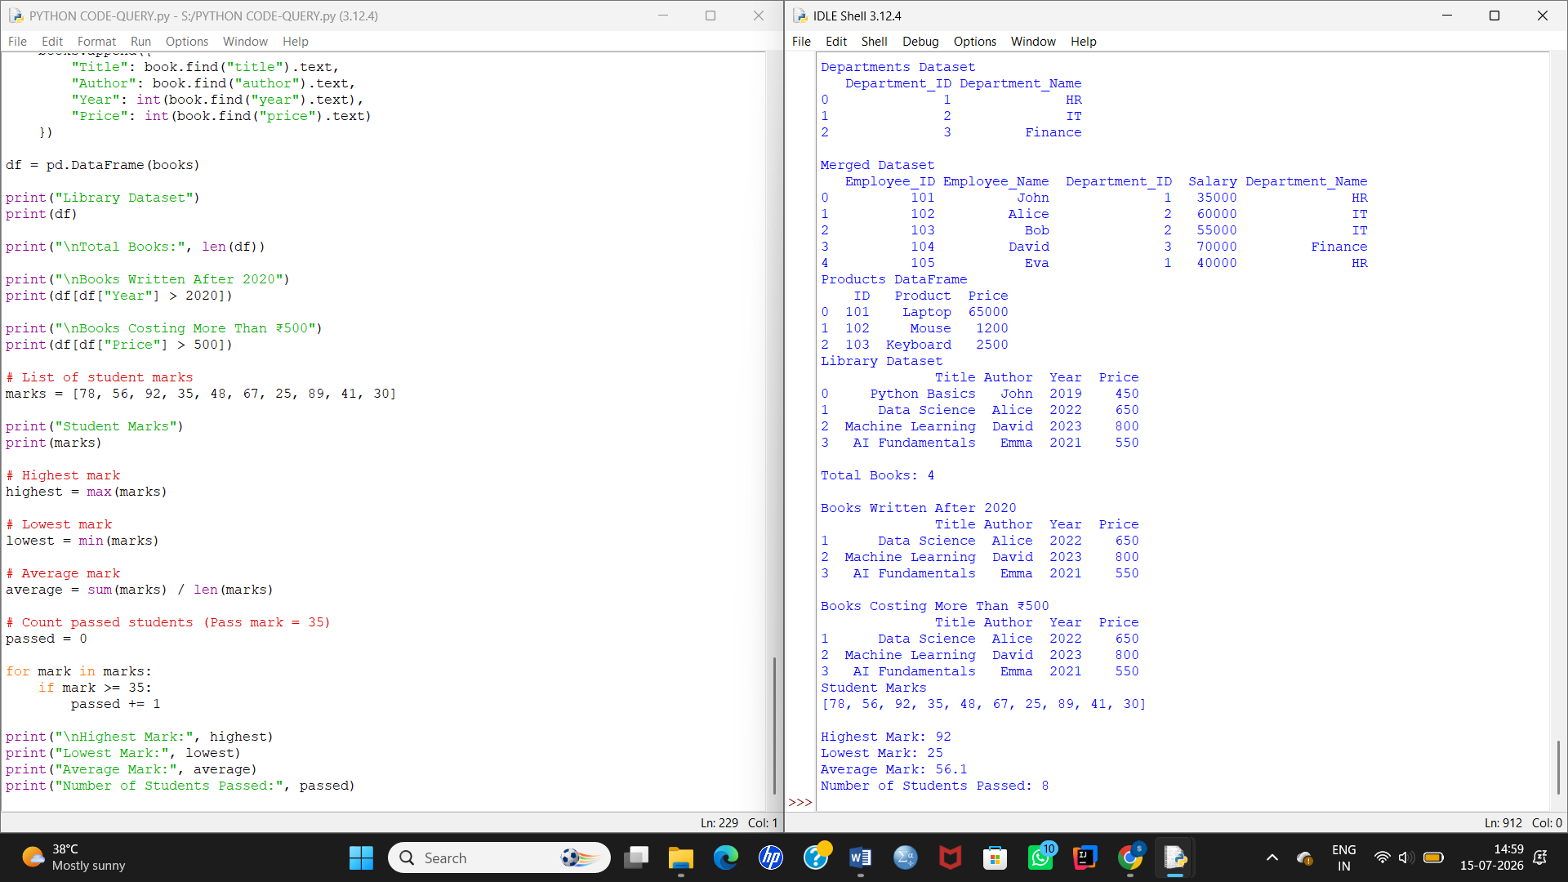

Conclusion
The student marks were successfully stored in a Python list. Using built-in functions and a loop, the highest mark, lowest mark, average mark, and the number of students who passed were calculated efficiently.

